An opportuntiy for community members to participate in On-the-Land Travel Program at Fletcher Lake, northeast of Gahcho Kue diamond mine” 63*42’28.08”N x 108*46’42.84”W

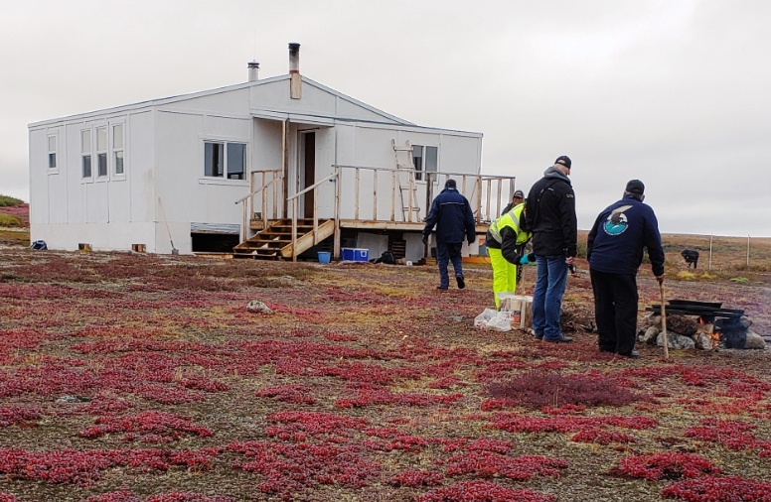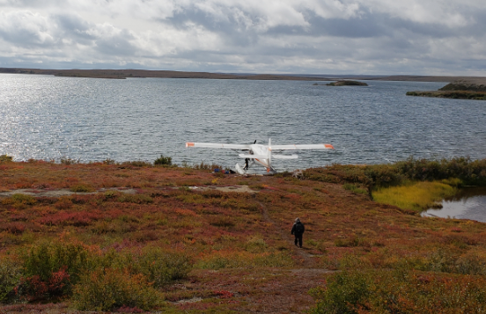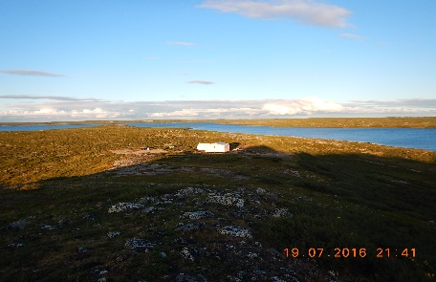

The Ni Hadi Xa On-the-Land Travel Program
The program aims to strengthen and maintain cultural knowledge of the land, water, wildlife, plants and resources throughout the life of the Gahcho Kue Mine, and to provide groups and individuals the opportunity to engage in traditional knowledge research and monitoring of the mine.
The On-the-Land Travel Program will provide funding for up to three groups to travel to the Ni Hadi Xa cabin for approximately 6 days each, between July 1 – September 30, 2023. The travel groups will be selected through a respective selection process by the Ni Hadi Xa Governance Committee. The travel will be coordinated by the community and funding per trip will be provided to the community. The deadline to apply is April 10, 2023.

How to Apply:
- Submit a completed application form along with your letter of intent and signed consent form.
*see application for more details

For more information please contact Rosy Bjornson, Environment Manager: Rosy.Bjornson@nihadixa.ca
visit our website: www.nihadixa.ca
COVID-19 GNWT Restrictions will apply; social distancing and when not possibly masks to be used and hand santizer when entering any small aircraft, boat, or cabin.

