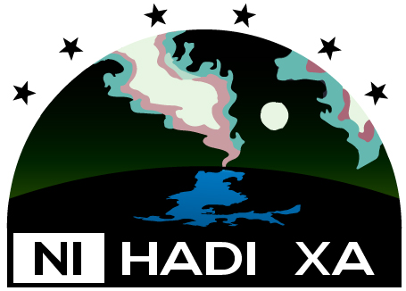 | 1. Application Form  2019 On-the-Land Travel Program

Deadline to apply is June 14th 2019

Applicant Information

Name

Address

Community

Phone:

Email

Participant Information
In addition to the applicant, the following people will be attending (maximum 6 people):

Member 1:

Member 2:

Member 3:

Member 4:

Member 5:

Member 6:

Preferred Dates
Applicants can request stays of up to 6 nights between July 1st and August 31st 2019. Dates cannot be guaranteed. Ni Hadi Xa will do its best to meet the requested selections but must work within strict timelines to deliver the program on budget and on time.
Request:
FROM: (day)________________(month)__________________________, 2019
TO: (day)________________(month)__________________________, 2019

2. Letter of Intent

2019 On-the-Land Travel Program
The purpose of the On-the-Land Travel Program is to provide an opportunity for beneficiaries of the Ni Hadi Xa Agreement members (Deninu Kué First Nation, Łutsel K’é Dene First Nation, North Slave Métis Alliance, Northwest Territory Métis Nation, Tłı̨chǫ Government, and Yellowknives Dene First Nation) to strengthen and maintain cultural knowledge of the land, water, wildlife, plants and resources throughout the life of Gahcho Kue Mine; and provide an opportunity to engage in research and monitoring in the region of the Mine.

Please use the space provided below to describe your main motivation for applying to this program and list any activities that you hope to take part in while on the land:

3. Consent Form

2019 On-the-Land Travel Program

Please review all the documentation available. The deadline for application hand in is June 14th, 2019. Following this, the applicants selected will be contacted and further paperwork will need to be completed, including establishing a final schedule and signing required program waivers.
I here-by agree to the terms of the application process and provide consent for Ni Hadi Xa to conduct necessary checks to determine applicant eligibility and accuracy of the information provided in this application package.

Signature |  | Date
Name (Please Print)

How to submit your application:
By post:
Ni Hadi Xa
General Delivery
Fort Resolution, NT
X0E 0M0

In person:
You can deliver your application in person, in a sealed envelope, to your local Ni Hadi Xa representative at one of the following locations:

Behchoko: Tlicho Government Office - Joline Huskey: jolinehuskey@tlicho.com
Lutsel K’e: Lutsel K’e Dene First Nation Office - Gloria Enzoe: gloriaenzoe@hotmail.com
Fort Resolution: Ni Hadi Xa Office - Rosy Bjornson: rosy.bjornson@nihadixa.ca
Yellowknife: Yellowknives Dene First Nation - Johanne Black: jblack@ykdfn.com
Yellowknife: North Slave Metis Alliance Office - Jess Hurtubise: Jess.Hurtubise@nsma.net
Online: www.nihadixa.ca
By Email: Rosy.Bjornson@nihadixa.ca

